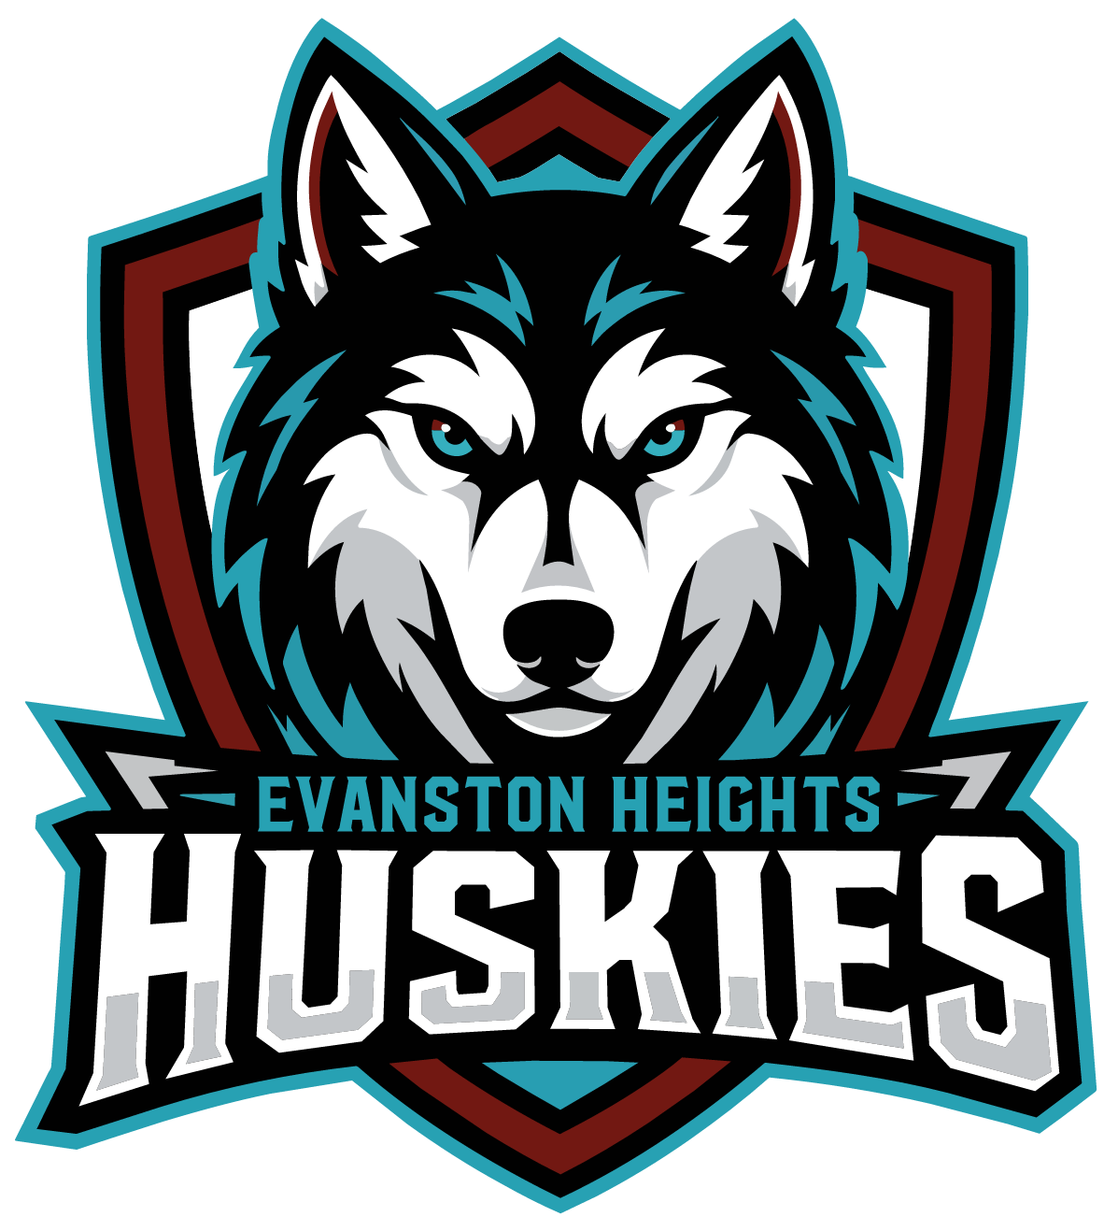chool
logo
In recognition of National Day for Truth and Reconciliation,
and in alignment with the CBE Education Plan,
Evanston Heights School
acknowledges and supports the Truth and Reconciliation Commission of Canada’s (TRC) Calls to Action, and makes the following commitment to action for the 2026-2027 school year:
Actively create opportunities for students, staff, and families to learn about and engage in Indigenous land-based and place-based learning (Body – To Do; Connects to TRC Call to Action 62.2)
Date: September 29, 2026

